ASSIGNMENT[07-02-22]:

# QUESTION 1: Registration Form with was-validated:

## CODE: <BODY>

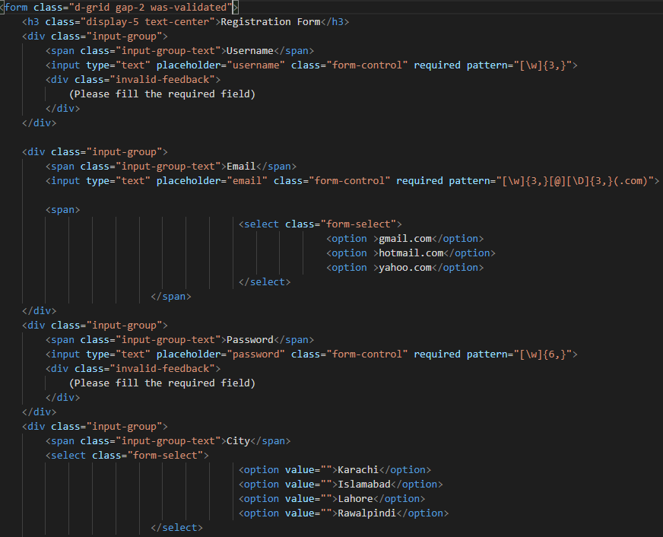

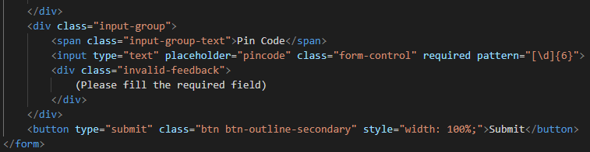

## <STYLE>

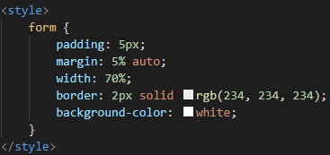

OUTPUT:

## Screenshot 2022-02-08 220111.png

# QUESTION 2: Registration Form with needs-validations:

## CODE: <BODY>

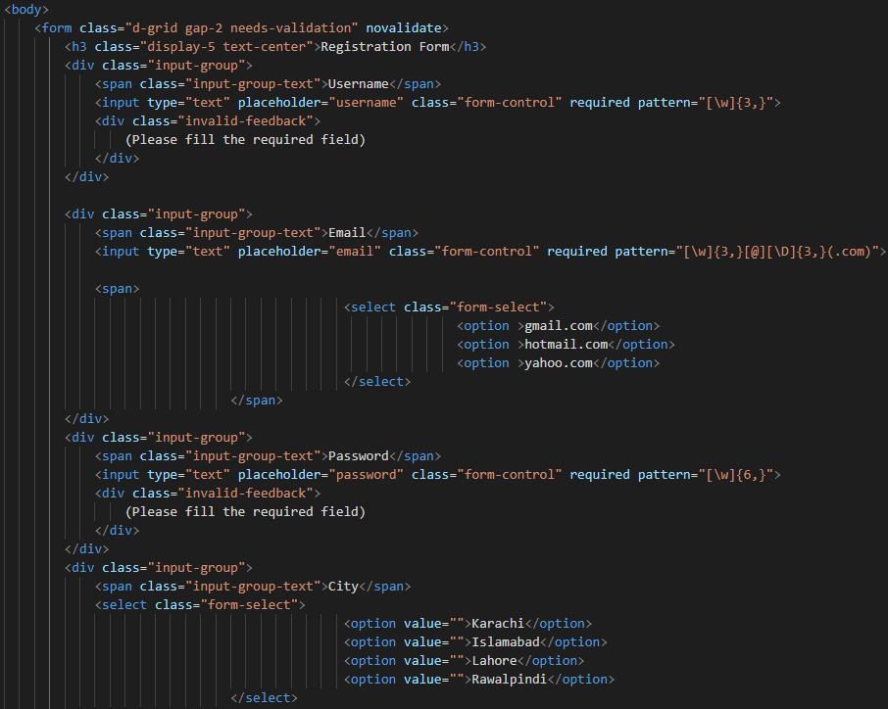



## <STYLE>



## <SCRIPT>

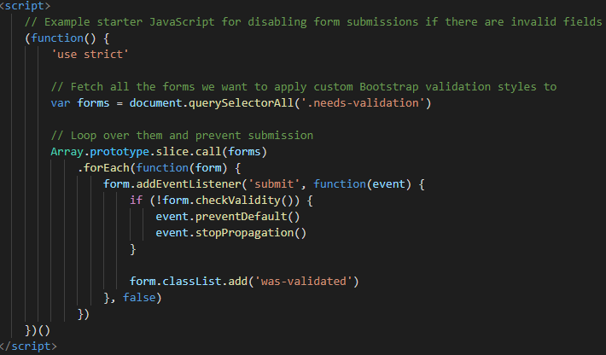

## OUTPUT:

